Press Kit 26.9.2021
for Voices of the Ancestors Podcast

Contains
- Description (inc. quote) p1
- How to Listen to the Podcast p2
- Support Voices of the Ancestors p3
- Find Us on Social p3
- Images – Hosts p3 – 4
- Images - Logo p5 - 6
- Holly Taylor-Zuntz p7
- Susan Thompson p7
- Contact Information p8

Description
Voices of the Ancestors is a captivating monthly podcast exploring Georgian polyphonic songs and the women who sing them. Do you love exploring different cultures? Are you uplifted by folk-stories and songs? Then ‘Voices of the Ancestors’ is the show for you. ‘Bee’s’ 5 star review says it all -

“such an interesting podcast, featuring beautiful voices, stories and songs from Georgia. Full of emotion, heart and wonderful music. I had no knowledge of this topic before listening, but love hearing from the people, teachers and singers of these traditional songs - a hidden gem of the world.”

Hosted by Holly Taylor-Zuntz and Susan Thompson. Two British women, who have been enchanted by this music genre - and they’re not the only ones - UNESCO proclaimed Georgian polyphony an ‘Intangible Cultural Heritage of Humanity’. In the Podcast Holly and Susan speak to women singers of Georgian polyphonic songs, both in Georgia and abroad. They discuss the journey of the songs and the stories behind them. The list of guests spreads across the globe, wherever folks have been touched by the harmonies of Georgia. In series one you hear Joan Mills,Voice Director at The Centre for Performance Research; Nino Naneishvili leader of Geogian women’s ensemble Ialoni; Magda Kevlishvili co-leader of Ethnomusic Theatre after Edisher and Gigi Garakanidze, Mtiebi and children’s ensemble Amer-Imeri; Dr Nana Mzhavanadze and Briget Boyle, voice coach and singer with american ensembles Kitka and True Life Trio.
So where do the ancestors come in? Well, these ancient songs have been passed down from generation to generation, and now they are being passed on to those outside of Georgia, by a new generation of teachers. You feel connected to the past when you sing them and you can feel the ancestors’ energy in the music.

Quote from Vanio Papadelli, London-based independent movement/physical theatre artist and regular lecturer in various HE Institutions (Goldsmiths, Rose Bruford College and Trinity Laban Conservatoire of Music and Dance), Movement Director.

“ Wow! You're passionate and share so much knowledge and wonderful women singers' voices. I'll listen to the last one slowly over the week. Oh thanks for pointing me to these. Truly inspiring and they're taking back to my days with ‘Song of the Goat’. Also, I"m co-running a workshop for women on ancestry/roots in March so you've given me some inspiration for the music. And have been looking into circular dances as well so thanks for your podcasts!”

How to Listen to ‘Voices of the Ancestors’ Podcast (A 1,2,3 guide)

1. Here is our show’s website www.voicesoftheancestors.co.uk - you can find all the episodes and transcripts on the website.
2. Here is how you listen to an episode:-
If you have never listened to a podcast before, go to our website www.voicesoftheancestors.co.uk on the homepage you click on the latest episode or the shorter introductory trailer.

If you are a seasoned podcast listener you can find us on these platforms:-
Soundcloud:https://soundcloud.com/voicesoftheancestors
Apple Podcasts: Bitly link: https://apple.co/32o8o3h
https://podcasts.apple.com/.../voices-of-the.../id1535335253
Spotify: Bitly link: https://spoti.fi/2GDvoDP
https://open.spotify.com/show/0yjDlYlQRU6VQAXEbbhR3x?si=d9qjxesfT9SpKbr-Suj20w
Google Podcasts: Bitly link: https://bit.ly/357zpd9
https://www.google.com/podcasts?feed=aHR0cHM6Ly9mZWVkcy5zb3VuZGNsb3VkLmNvbS91c2Vycy9zb3VuZGNsb3VkOnVzZXJzOjg4NzkyOTgxNi9zb3VuZHMucnNz&fbclid=IwAR1iT5JaC95aTsmhtT2kavziu97pV7Pvd6TvEgEv49J_1_HwiRkF7PYQGDU
Amazon Podcast:
https://www.amazon.com/Voices-of-the-Ancestors/dp/B08K582DLV/ref=sr_1_1?dchild=1&keywords=Voices+of+the+Ancestors&qid=1612595229&s=audible&sr=1-1
3. Here’s a great episode to start with Episode 3: Healing Songs and Circle Dances with Nino Naneishvili
Enjoy!"

Support Voices of the Ancestors
by joining the mailing list or donating a cup of coffee/mint tea at Ko-fi
or become a patron of the podcast at
https://www.patreon.com/voicesoftheancestors.

Find us on Social
Twitter: @VoicesAncestors
https://twitter.com/VoicesAncestors
Facebook: @georgianpolyphony
https://www.facebook.com/watch/georgianpolyphony/
Instagram: https://www.instagram.com/voicesoftheancestors/
Wordpress Blog: https://voicesoftheancestors.wordpress.com/
Sara Pascoe in Georgia
Youtube: https://www.youtube.com/channel/UC9iEXuhX7g6xhtMn4pIfKqA
Ko-fi: https://ko-fi.com/voicesoftheancestors
Patreon: https://www.patreon.com/voicesoftheancestors
Mailing list sign up: http://eepurl.com/hhgoOf

Images
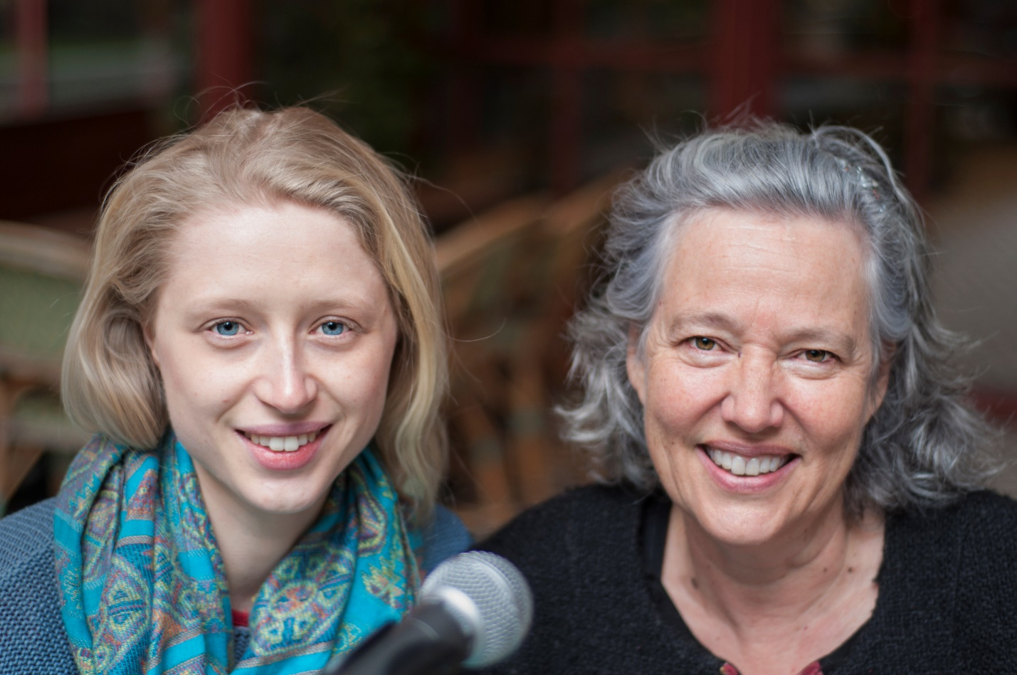
Photo by Nino Khundadze
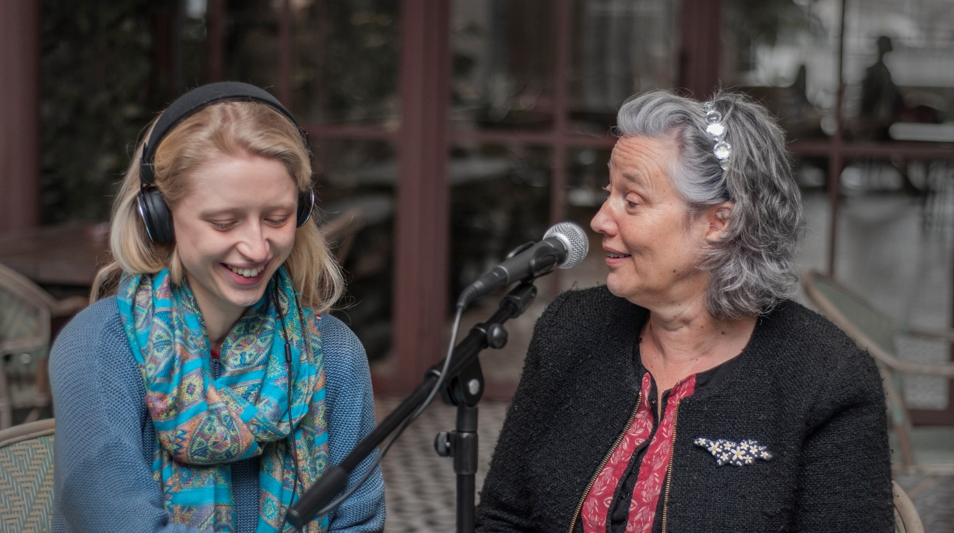
Photo by Nino Khundadze

Logo no background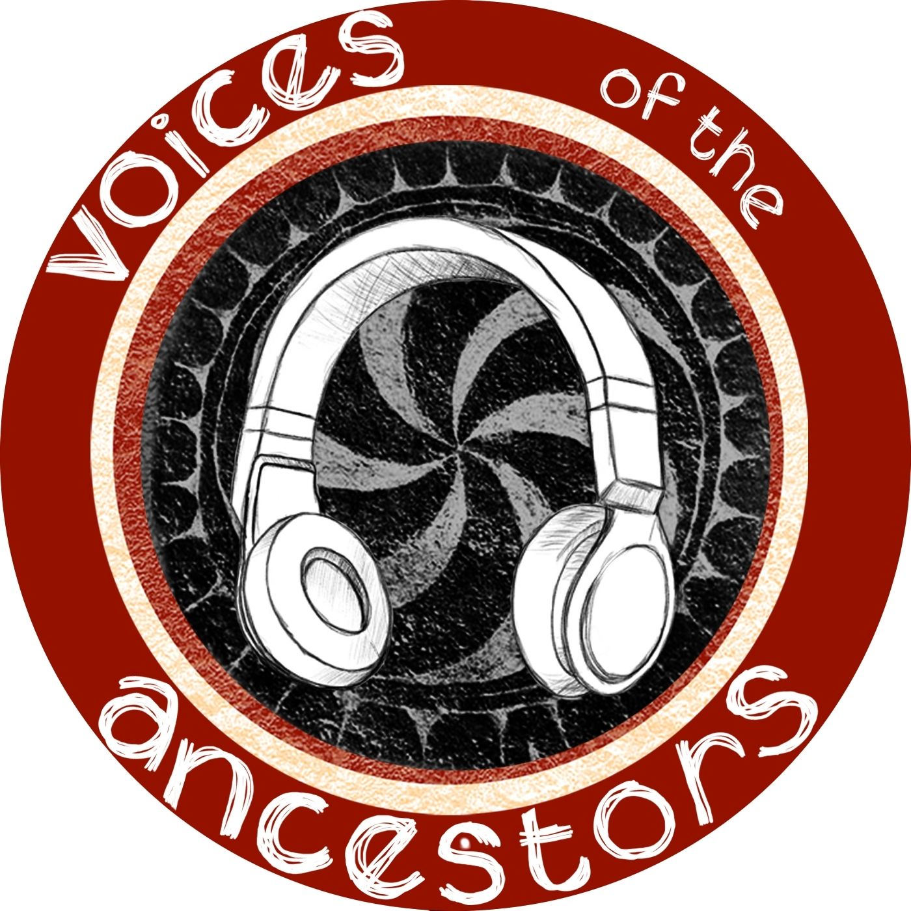
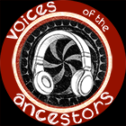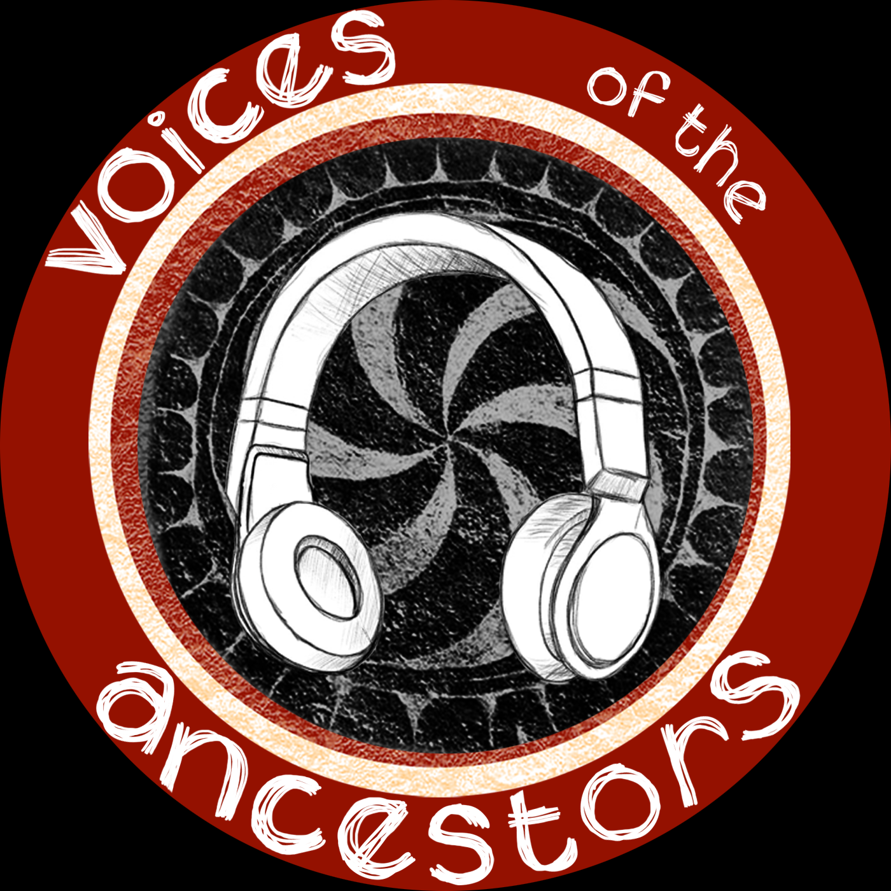

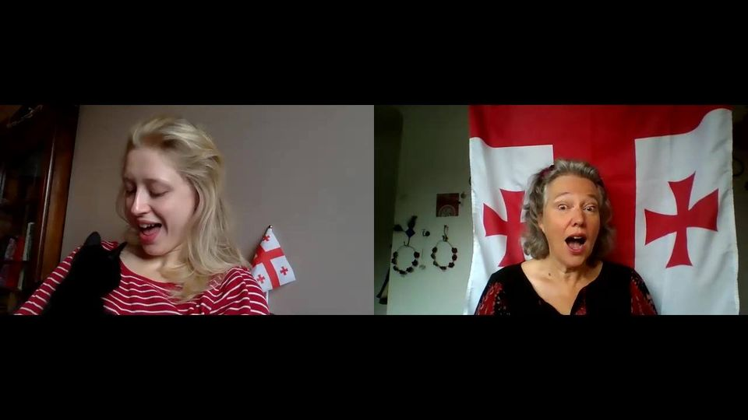

Holly Taylor-Zuntz
Holly is a theatre maker and singer, who loves to learn songs from all over the world and share them with others. She is a graduate of the European Theatre Arts (BA) Programme at Rose Bruford College, London's International Drama School of Theatre & Performance. She trained in ensemble theatre and devising. Since then she has been researching Georgian polyphonic songs and teaching singing. She is co-artistic director of Planet B Productions, an Oxford-based immersive political theatre company.
As Holly says in Episode 7 - "When I was training in Gardzienice in Poland, I was introduced to Georgian songs, and I was just completely blown away and fascinated. Later that year I went to Georgia and of course fell in love with the country and the folk songs."

Susan Thompson
Susan is a Georgian polyphonic folk song enthusiast. Her moment of discovery was while singing with 'Woven Chords', a community choir in Stamford, UK. Joining Maspindzeli in 2004 and performing both in Georgia and the UK, Susan has travelled widely in Georgia. She attended many of the International Symposia on Traditional Polyphony in Tbilisi and the Giorgi Garakanidze International Festival of Folklore and Spiritual Music in Batumi.
In 2019 Maka Khardziani interviewed her for the Bulletin of the International Research Centre for Traditional Polyphony of the V. Sarajishvili Tbilisi State Conservatoire: Voices of the Ancestors - An English Woman's Journey through Georgian Folk Songs and Singers Bulletin 27.

Contact Information
We regularly check: voicesofancestors@gmail.com
If you need an urgent response:
Holly Taylor-Zuntz hollytaylor575@gmail.com
Mob +44 7889 850049
Susan Thompson susathompson@gmail.com
Mob +995 574 11 42 95

