Press Kit 6.2.2021
for Voices of the Ancestors Podcast

Contains
- Description (inc. quote) p1
- How to Listen to the Podcast p2
- Support Voices of the Ancestors p2
- Find Us on Social p2
- Images p3
- Contact Information p5

Description
Voices of the Ancestors is a captivating monthly podcast exploring Georgian polyphonic songs and the women who sing them. Do you love exploring different cultures? Are you uplifted by folk-stories and songs? Then ‘Voices of the Ancestors’ is the show for you. ‘Bee’s’ 5 star review says it all -

“such an interesting podcast, featuring beautiful voices, stories and songs from Georgia. Full of emotion, heart and wonderful music. I had no knowledge of this topic before listening, but love hearing from the people, teachers and singers of these traditional songs - a hidden gem of the world.”

Hosted by Holly Taylor-Zuntz and Susan Thompson. Two British women, who have been enchanted by this music genre - and they’re not the only ones - UNESCO proclaimed Georgian polyphony an ‘Intangible Cultural Heritage of Humanity’. In the Podcast Holly and Susan speak to women singers of Georgian polyphonic songs, both in Georgia and abroad. They discuss the journey of the songs and the stories behind them. The list of guests spreads across the globe, wherever folks have been touched by the harmonies of Georgia.
So where do the ancestors come in? Well, these ancient songs have been passed down from generation to generation, and now they are being passed on to those outside of Georgia, by a new generation of teachers. You feel connected to the past when you sing them and you can feel the ancestors’ energy in the music.

How to Listen to ‘Voices of the Ancestors’ Podcast (A 1,2,3 guide)

1. Here is our show’s website www.voicesoftheancestors.co.uk - you can find all the episodes and transcripts on the website.
2. Here is how you listen to an episode:-
If you have never listened to a podcast before, go to our website www.voicesoftheancestors.co.uk on the homepage you click on the latest episode or the shorter introductory trailer.

If you are a seasoned podcast listener you can find us on these platforms:-
Soundcloud:https://soundcloud.com/voicesoftheancestors
Apple Podcasts: Bitly link: https://apple.co/32o8o3h
https://podcasts.apple.com/.../voices-of-the.../id1535335253
Spotify: Bitly link: https://spoti.fi/2GDvoDP
https://open.spotify.com/show/0yjDlYlQRU6VQAXEbbhR3x?si=d9qjxesfT9SpKbr-Suj20w
Google Podcasts: Bitly link: https://bit.ly/357zpd9
https://www.google.com/podcasts?feed=aHR0cHM6Ly9mZWVkcy5zb3VuZGNsb3VkLmNvbS91c2Vycy9zb3VuZGNsb3VkOnVzZXJzOjg4NzkyOTgxNi9zb3VuZHMucnNz&fbclid=IwAR1iT5JaC95aTsmhtT2kavziu97pV7Pvd6TvEgEv49J_1_HwiRkF7PYQGDU
Amazon Podcast:
https://www.amazon.com/Voices-of-the-Ancestors/dp/B08K582DLV/ref=sr_1_1?dchild=1&keywords=Voices+of+the+Ancestors&qid=1612595229&s=audible&sr=1-1
3. Here’s a great episode to start with Episode 3: Healing Songs and Circle Dances with Nino Naneishvili
Enjoy!"

Support Voices of the Ancestors
by joining the mailing list or donating a cup of coffee/mint tea at Ko-fi.

Find us on Social
Twitter: @VoicesAncestors
https://twitter.com/VoicesAncestors
Facebook: @georgianpolyphony
https://www.facebook.com/watch/georgianpolyphony/
Instagram: https://www.instagram.com/voicesoftheancestors/
Wordpress Blog: https://voicesoftheancestors.wordpress.com/
Sara Pascoe in Georgia
Ko-fi: https://ko-fi.com/voicesoftheancestors
Mailing list sign up: http://eepurl.com/hhgoOf

Images

Logo no background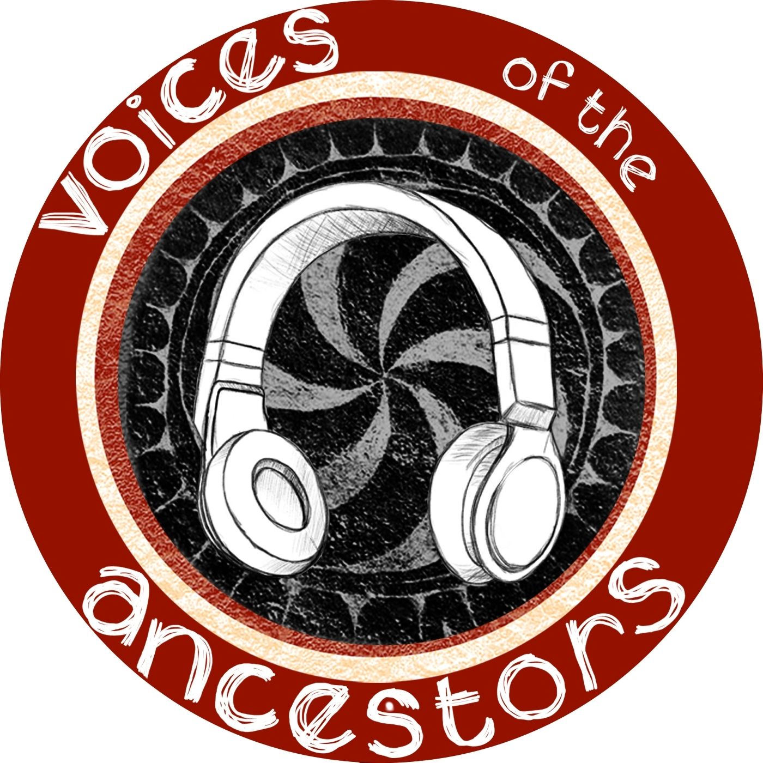
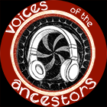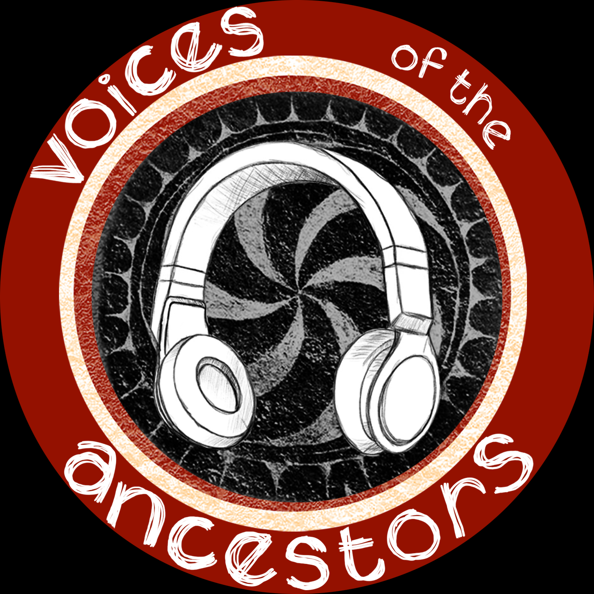

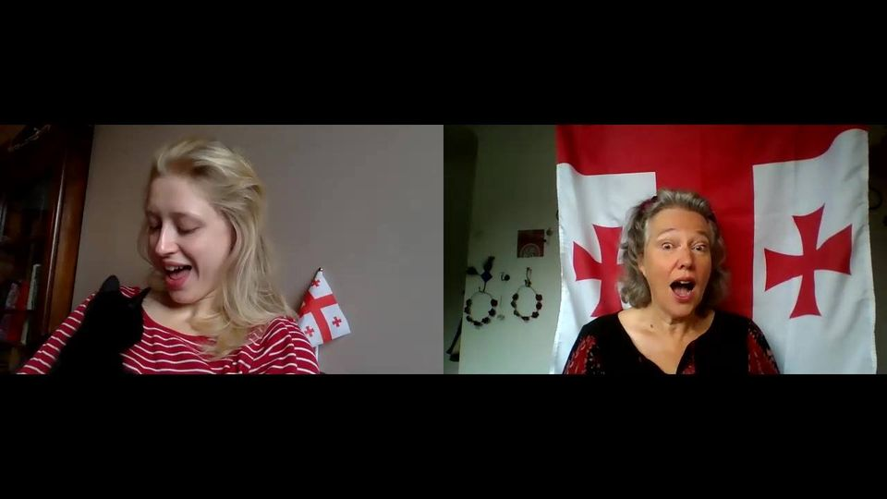

Contact Information
We regularly check: voicesofancestors@gmail.com
If you need an urgent response:
Holly Taylor-Zuntz hollytaylor575@gmail.com
Mob +44 7889 850049
Susan Thompson susathompson@gmail.com
Mob +995 574 11 42 95

